March 2024 | 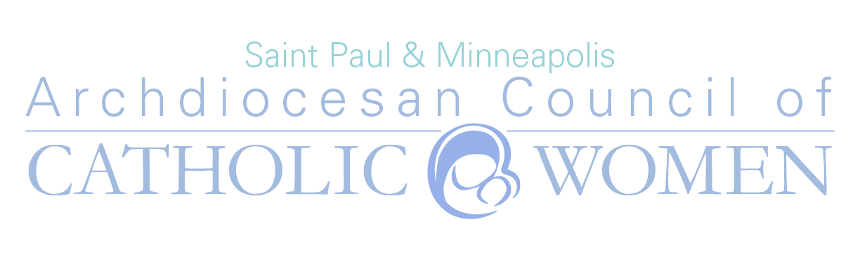
Vocation Prayer for those on their journey to ordination/final vows.

Loving God, we ask you to guide the men and women of this Archdiocese who are considering religious life and those already on their journey towards ordination or final vows. Bless them in their decisions; strengthen them in their love for you and their desire to serve you in this special way. Hold them all close to your heart, especially during difficulty or troubled times. Shower them with your love and fill them with courage and joy as they study and prepare themselves for your work. We pray for all on their journey to religious life. May they feel our loving and prayerful support. We ask this in the name of Jesus, Your Son. Amen. www.accwarchspm.org
Sunday | Monday | Tuesday | Wednesday | Thursday | Friday | Saturday
 |  |  |  |  | 1 | 2
 |  |  |  |  | Alexander Rasset  Br. Didacus | Ryan Sustacek  Br. Jonathan Hank
3 | 4 | 5 | 6 | 7 | 8 | 9
Nicholas Vance  Br. Mark Engelmeyer | Joseph Wappes  Br. Mary Peter | Pope Francis  Br. Backstrom | Archbishop Hebda  Br. Paul Joseph | Christopher Yanta  Dan Berning | Benjamin Eichten  Dan Sherber | Alexander Marquette  8 Young Women in Formation-Handmaids of the Heart of Jesus
10 | 11 | 12 | 13 | 14 | 15 | 16
Zachary Ochsenbauer  Frater Titus Blackman | Randy Skeate  Gabriel Mackinness | Those in discernment of a vocation  Little Sister Candice | Bishop Williams  Sawyer Phillips | Charles DeReuill II  Seminarian Leo Rander | Dominic Miller  Sr. Anne Immaculee | Steven Lang  Sr. Eliya & Sr. Seraphine
17 | 18 | 19 | 20 | 21 | 22 | 23
Eric Miller  Sr.M. Gianna Agnes Popp, MC | Peter Romens  Sr. Maria Francisco, OP | Deacons  Sr. Martha Maria Guadalupe | Bishop Izen  Sr. Mary Bridgette | Sebastian Spencer  Sr. Sophia Thomas Coulter | Joshua French  Travis Spillum | Joshua Gerads  Jermiah Kracker
24 | 25 | 26 | 27 | 28 | 29 | 30
Jacob O’Meara | Andrew Reiner | Religious Brothers | Religious Sisters | Jacob Robbins | Dominic Wolters | Thomas Cain
31

